Chapter 9: Molecular Geometry and Bonding Theories



# Section 1: Molecular Shape



* Lewis Structures do not indicate the shapes of molecules; they simply show the number and types of bonds and unpaired electrons.
* CCl₄ for example has a lewis structure with the carbon atom in the center and the chlorine atoms surrounding it.

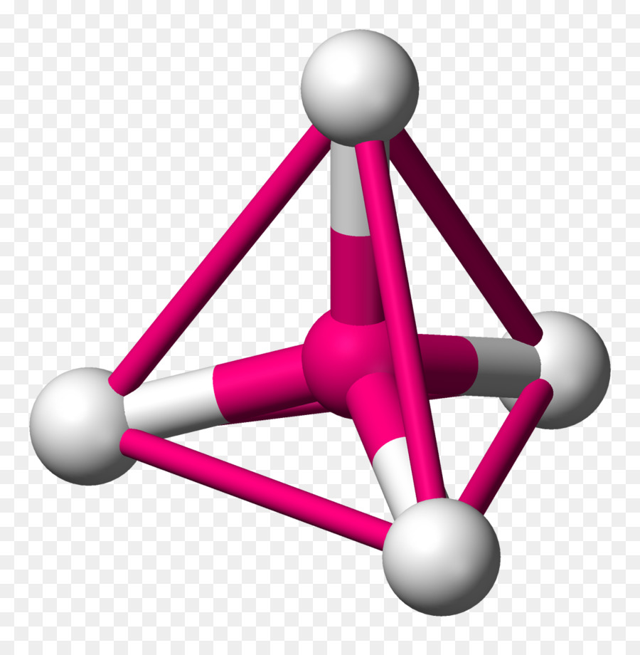

* + In reality it creates a tetrahedron, with a bond angle of 109.5
  + All bonds are the same length: 1.78 Å

*[Section Intentionally Left Blank]*

* **Molecular shapes**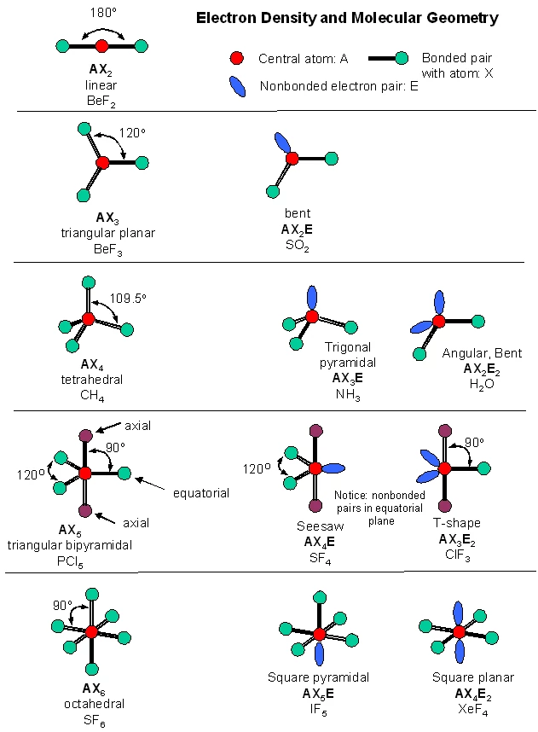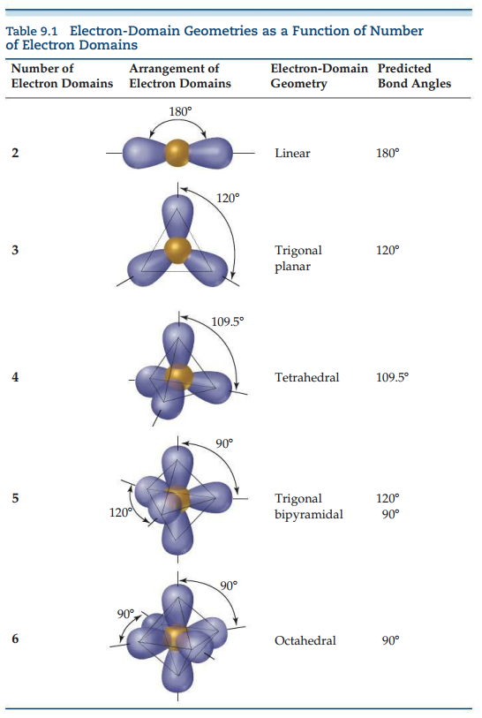
* We can determine the shape of the molecule with the VSEPR model

# Section 2: The VSEPR Model



* Bonding pair electrons define a region in which electrons are most likely to be found; known as electron domain.
* Nonbonding pair(lone pair) of electrons define an electron domain that is located principally on one atom.
* The VSEPR model is based on the idea that electron domains are negatively charged(due to the electrons) and therefore repel one another(***Think pushing the same poles of a magnet together***)
  + Domains try to stay out of each other’s way.
* The best arrangement of a given number of electron domains is the one that minimizes the repulsion among them.
* The molecular geometry involves only electron domains due to bonds

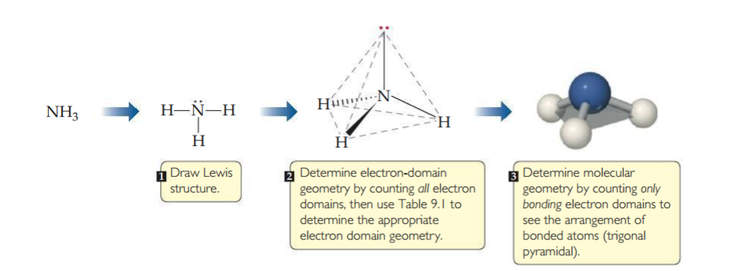

* **Predicting Molecular Geometry with VSEPR Model**

1. Draw the Lewis structure of the molecule or ion, and count the number of electron domains around the central atom. Each nonbonding electron pair, each single bond, each double bond, and each triple bond counts as one electron domain.
2. Determine the electron-domain geometry by arranging the electron domains about the central atom so that the repulsion among them are minimized.
3. Use the arrangement of the bonded atoms to determine the molecular geometry

* The bond angle for a linear pair is 180 or if it is bent ≠ 180

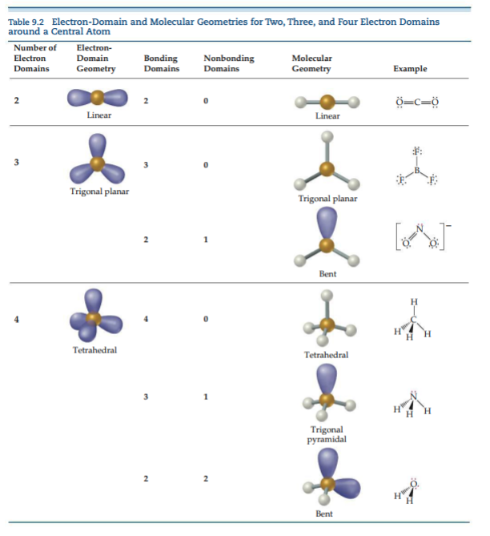

## Effect of Nonbonding Electrons and Multiple Bonds on Bond Angles

* Bond angles decrease as the number of nonbonding electron pairs increases.
  + Electron domains for nonbonding electron pairs exert greater repulsive force on adjacent electron domains and tend to compress bond angles.
* Nonbonding electron domains take up more space the bound domains

## Molecules with Expanded Valence Shells

* Atoms from period 3 and beyond may be surrounded by more than four electron pairs.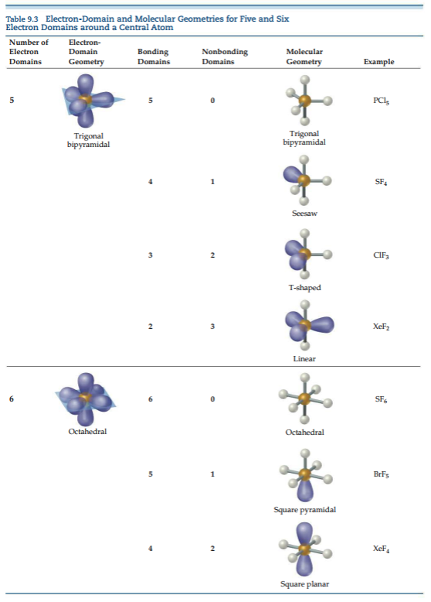

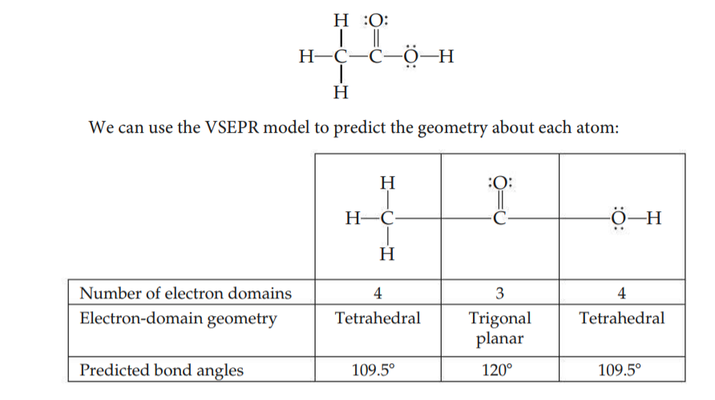

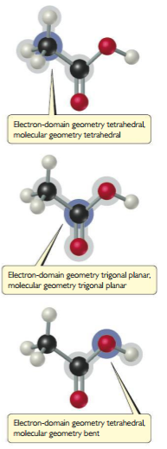

# Section 3: Molecular Shape and Polarity



## Bond Polarity and Dipole Moments

* Remember that as the difference in electronegativity increases between two atoms increases, so does the bond polarity.
  + Non-Polar → Polar → Ionic
  + Difference in electronegativity is in reference two taking two atoms and subtracting the larger electronegativity from the smaller one and using that to calculate what type of bond it will have.
* Dipole moments of a diatomic molecule is a measure of the amount of separation in the molecule.
* For a molecule consisting of more than two atoms, the dipole moment depends on both the polarities of the individual bonds and the geometry of the molecule
* For each bond in the molecule, we consider the bond dipole.
* **How to find the overall dipole moment of the molecule?**
  + Bond dipoles and dipole moments are *Vector quantities*(Going back to Pre-Cal/Physics) meaning that they both have magnitude and direction
  + The dipole moment of a polyatomic molecule is the vector sum of its bond dipoles
    - Magnitude is the # or how polar it is
    - Direction is the charge (+ or -)
  + An overall non-zero dipole moment is a polar molecule
  + If the sum is equal to zero it is a nonpolar molecule

## Acree’s Notes

* Molecules have dipoles that can either add or cancel out depending on the direction of the partial charge
* If the pull of the atoms from the central atom is equal on all sides with an atom, the molecule is nonpolar.
  + Carbon Dioxide is a good example of this due to the pull of both oxygen atoms pulling away from the central atom making it a nonpolar molecule.
  + While this is true, Take the water molecule for example, the hydrogen is heading towards the central atom which gives the hydrogen a partial positive and the oxygen a partial negative allowing them to stick together creating the polar molecule.
* Vectors are mewasurements with a **Magnitude** and **Direction**.
  + If they are pointing in the same direction, they add together.
  + If they are pointing in opposite direction, they can cancel out.
* Theses geometries can have M = O even with all polar bonds!
  + Linear
  + Trigonal Planar
  + Tetrahedral
  + Square planar
  + Trigonal Bipyramidal
  + Octahedral

# Section 4: Covalent Bonding and Orbital Overlapping



* **Bonding Theories**
  + In Lewis Theory, covalent bonding occurs when atoms share electrons because the sharing concentrates electron density between the nuclei.
  + Meaning when two orbitals overlap they are creating a covalent bond due to the increased density caused by the electrons.
  + In Valence-Bond Theory, we visualize the buildup of electrons density between two nuclei as occurring when a valence atomic orbital of one atom shares space, or overlaps, with a valence atomic orbital of another atom.
  + Think of it as taking one orbital and ***overlapping*** another orbital to create bonds.
    - The overlap of orbitals allows two electrons of opposite spin to share the space between the nuclei, forming a covalent bond.

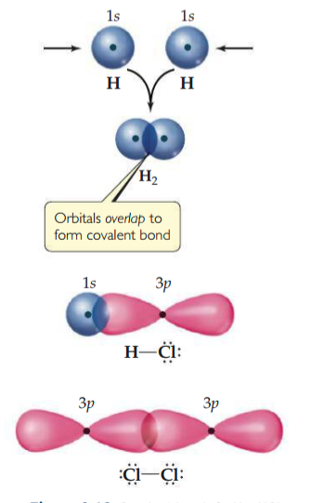

* + In the example above, the two hydrogen atoms coming together to form a single molecule, the orbitals overlap causing the concentration of the electron density between the two nuclei.
    - Because the electrons in the overlapping region are simultaneously attracted to both nuclei, they hold the atoms together forming a covalent bond.
    - This image from Chapter 8 should help visualize what is happening between the two hydrogen electrons:

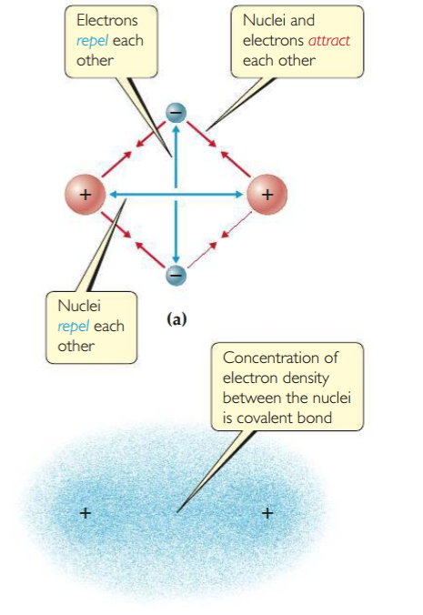

## Optimal Distances

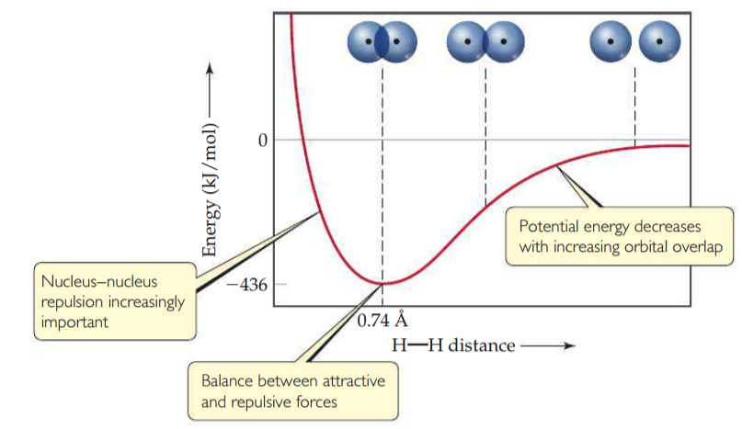

* + There is always an optimal distance between the two nuclei in any covalent bond.
    - As the atoms get infinitely farther apart their potential energy gets closer and closer to zero.
    - As atoms get farther apart they lose potential energy.(Energy that could possibly be released[Exothermic reaction to bond])
    - As the distance between the two atoms decreases, the overlap between their orbitals increases.Because of the increase in electron density between the two nuclei, the potential energy of the system decreases.
      * With the potential energy decreasing, the covalent bond increases.
    - At a point where the atoms get too close to each other, the potential energy increases dramatically.
      * This is due mainly to the electrostatic repulsion between the nuclei
  + The internuclear distance at the minimum of the potential-energy curve corresponds to the bond length of the molecule
    - The observed bond length is the distance at which the attractive forces between unlike charges are balanced by the repulsive forces between like charges.
    - The attractive forces between the protons and electrons is balanced from the repulsive forces of the protons together and the electrons together(think about them as magnets with only one pole)
    - Refer back to the picture above with the image showing the attraction and repulsion of the electrons and protons to give you a visual.

## Acree’s Notes

* **Valence-bond theory** predicts that bonds occur where atomic orbitals overlap
  + Half-filled orbitals overlap to share e⁻, which increases their e⁻ density so they BECOME FILLED.
* The amount of overlap is determined by the bond length that results in the LOWEST energy.
  + Negative energy means attraction
  + Positive energy means repulsion
* Energy is negative when charges are opposite
* Energy is positive when charges are alike.

# Section 5: Hybrid Orbitals



* To explain molecular geometries, we often assume that the atomic orbitals on an atom (usually the central atom) mix to form new orbitals called hybrid orbitals.
* The shape of any hybrid orbital is different from the shapes of the original atomic orbitals
* The total number of atomic orbitals on an atom remains constant, so the number of hybrid orbitals on an atom equals the number of atomic orbitals that are mixed.
* ***Sp* Hybrid Orbitals**

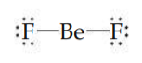

* + The electron configuration of F(1*s*²2*s*²2p⁵) indicates an unpaired electron in a 2*p* orbital.
  + This electron can be paired with an unpaired Be electron to form a polar covalent bond.
    - The orbital diagram for a ground-state Be atom is:

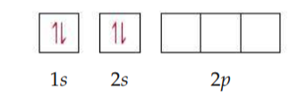

* + Because it has no unpaired electrons, the Be atom in its ground state cannot bond with the fluorine atoms.
  + The Be atom could form two bonds, however, by envisioning that we “promote” one of the 2*s*  electrons to a 2*p* orbital:

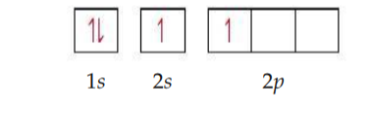

* + The Be atom now has two unpaired electrons and can therefore form two polar covalent bonds with F atoms.
  + The two bonds would not be identical, however, because a Be 2*s* orbital would be used to form one of the bonds and a 2*p* orbital would be used to form the other.
  + **The structure of BeF₂**
    - We can solve this dilemma by “mixing” the 2*s* orbital with one 2*p* orbital to generate two new orbitals.
    - Like *p* orbitals, each new orbital has two lobes.
    - Unlike *p* orbitals, however, one lobe is much larger than the other.
    - The two new orbitals, which are identical in shape, but their large lobes point in opposite directions.
    - These two new orbitals, which are shown in purple are hybrid orbitals.
  + Because we have hybridized one *s* and one *p* orbital, we call each hybrid an *sp* hybrid orbital.
  + *According to the valence-bond model, a linear arrangement of electron domains implies* sp *hybridization.*

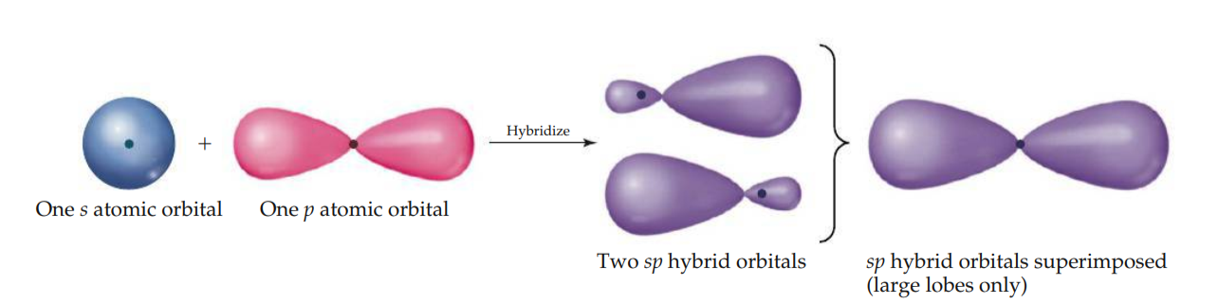

* ***sp²* and *sp³* Hybrid Orbitals**
  + Other combinations of atomic orbitals can be hybridized to obtain different geometries.
  + In BF₃, mixing the 2*s* and two of the 2*p* orbitals yields three equivalent *sp*² hybrid orbitals.
  + The three *sp*² hybrid orbitals lie in the same plane, 120° apart from one another
  + They are used to make three equivalent bonds with the three F atoms, leading to the trigonal-planar molecular geometry of BF₃.
    - Notice that an unfilled 2*p* atomic orbital remains unhybridized; it is oriented perpendicular to the plane defined by the three *sp*² hybrid orbitals, with one lobe above and one below the plane.
      * This unhybridized orbital will be important when we discuss double bonds .
  + The mixing of the 2*s* and all three 2*p* orbitals to create four equivalent *sp*₃³
* **Hypervalent Molecules**
  + So far our discussion of hybridization has extended only to period 2 elements, specifically carbon, nitrogen , and oxygen. The elements of period 3 and beyond introduce a new consideration because in many of their compounds these elements are **hypervalent**.
  + The VSEPR model works well to predict the geometries of hypervalent molecules such as PCl₅, SF₆, or BrF₅.
  + In short, the answer to this question is that it is bes *not*  to use hybrid orbitals for hypervalent molecules, as we now briefly discuss.

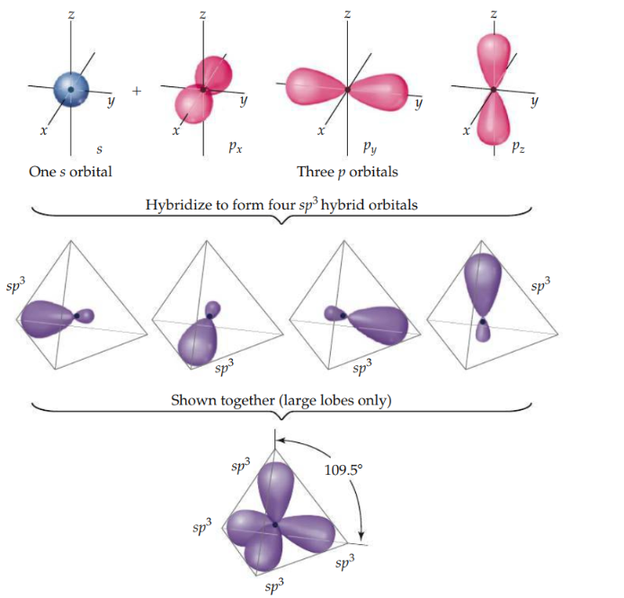

* **Hybrid Orbital Summary**
  + The following steps allow us to describe the hybrid orbitals used by an atom in bonding:

1. Draw the *Lewis structure* for the molecule or ion.
2. Use the VSEPR model to determine the electron-domain geometry around the central atom.
3. Specify the *hybrid orbitals* needed to accommodate the electron pairs based on their geometric arrangement

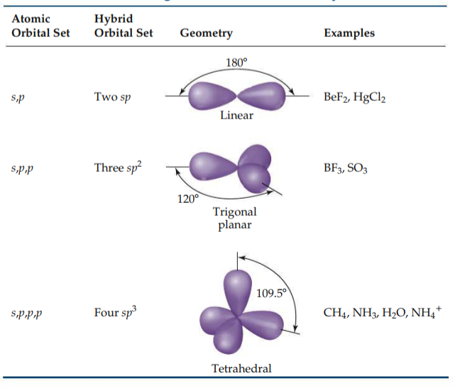

## Acree’s Notes

* **Hybridization** is one theory that explains molecular geometry with hybrid valence orbitals that mix their characteristics to all become homogeneous.

# Section 6: Multiple Bonds



* To describe multiple bonding, we must consider a second kind of bond, this one the result of overlap between two *p* orbitals oriented perpendicularly to the internuclear axis.
* A 𝝅 bond is one in which the overlap regions lie above and below the internuclear axis.
  + Unlike a 𝞼 bond, in a 𝝅 bond the electron density is not concentrated on the internuclear axis.
* The sideways orientation of *p* orbitals in a 𝝅 bond makes for weaker overlap.
  + As a result, 𝝅 bonds are generally weaker than 𝞼 bonds.
* **Triple Bonds**
  + Triple bonds can also be explained using hybrid orbitals.
  + Linear geometry suggests that each atom uses *sp* hybrid orbitals to form 𝞼 bonds with others.
  + Each atom thus has two unhybridized 2*p* orbitals at right angles to each other and to the axis of the *sp* hybrid set.
  + Thus, there are *two* orbitals remaining on an *sp*-hybridized atom.
    - These orbitals overlap to form a pair of ℼ bonds.

# Section 7: Molecular Orbitals



# Section 8: Period 2 Diatomic Molecules



# Definitions:



* **Section 1**
  + Bond Angles ~ The angles made by the lines joining the nuclei of the atoms in the molecule.
  + Valence-Shell-Electron-Pair-Repulsion(VSEPR) Model ~
* **Section 2**
  + Electron Domain ~
  + Electron-Domain Geometry ~ The arrangement of electron domains about the central atom of an ABₙ molecule or ion
  + Molecular geometry ~ The arrangement of only the atoms in a molecule or Ion
* **Section 3**
  + Bond dipole ~ the dipole moment due only to the two atoms in that bond.
* **Section 4**
  + Valence-Bond Theory ~ bonding electron pairs are concentrated in the regions between atoms, and nonbonding electron pairs lie in directed regions of space.
* **Section 5**
  + Hybrid orbitals ~
  + Hybridization ~ The process of mixing atomic orbitals by a mathematical operation
  + Hypervalent ~They have more than an octet of electrons around the central atom
* **Section 6**
  + Internuclear axis ~ In the covalent bonds we have considered thus far, the electron density is concentrated along the line connection the nuclei.
  + Sigma(𝞼) bond ~ The line joining the two nuclei passes through the middle of the overlap region, forming a type a of covalent bond.
  + pi(ℼ) bond ~ The sideways overlap of *p* orbitals to describe multiple bonds.
* **Section 7**
* **Section 8**

# Equation Help:

